CAREERS AT GREAT ACADEMY ASHTON
CEIAG ENTITLEMENT STATEMENT AND CURRICULUM INTENT
We want our students to be valuable citizens of society, community and country.
At Great Academy Ashton we believe that high quality careers advice, guidance and support are key in preparing students for their next steps in life and to manage those vital stepping stones from learning and training into the world of work.

We prepare our students to have high aspirations and provide careers education from year 7 to 11 with the intention for students to be prepared for life after Great Academy Ashton. Students need to reflect and evaluate their goals and use information obtained to help make decisions about career pathways.

We look at our offer as one fluid key stage from 7-11, where experiences and subject choice is built upon and layered. The development of key employability skills starts here and develops through to KS4. Skills are a key area that employers are looking for when they interview candidates and the way in which they communicate how they have developed these skills is crucial in the decision process made by employers about the candidate’s suitability for the role.
The language of careers will be introduced at this point in terms of working hours, types or employment and the law. Students will develop this knowledge further in year 11 when they are preparing to leave and are applying for jobs and college.
Dedicated careers lessons starting from year 7, highlight to students the importance of making informed decisions about their future. Through the exploration of a wide range of jobs and careers sectors students are able to not just consider well know careers but those that they may never have heard of or that don’t exist yet.
Careers lessons allows for more opportunities to invite local employers in to the academy to speak to students about their experiences. As a part of the Gatsby benchmarks this is key to the careers education of students and will allow for students to gain knowledge and understanding from local businesses.
Students are given the time to develop skills in personal finance and business finance. This is crucial in ensuring that students are able to be financially stable when they leave the academy and in their future. This will start will simply tasks such as how to set up a bank account and lead to considering saving and investments.
Enterprising skills are a theme right from the beginning of the careers curriculum. Ensuring students have the ability to be innovative, creative, able to problem solve, work independently, take risks and be resilient sets students up to be successful in any career.
In studying careers from year 7 to year 11 students will have an excellent understanding of the current labour market. They will be able to make informed decisions about their future based on their skills knowledge and interests. They will have the knowledge of the qualifications and experience they need to get to their chosen career and where they need to go to gain further support with this.

Our students will be able to market themselves as ambitious young people, with high aspirations. They will have an excellent C.V. and cover letter prepared. They will have had a number of opportunities to work on their communication with employers and have developed good interviews skills in preparation for college and the world of work.
Students will have developed a wide range of employability skills that can be transferred across any career. They will be able to set goals, assess their progress and identify further improvements they can make to succeed. They will be able to use these skills to transfer to jobs that do not even exist yet.
With this careers education, along with their qualifications, our students will have more opportunities and are more likely to be employed. This will then impact the local community, as Tameside’s unemployment rate would hopefully go down. There will be more young people actively participating to their local community, which will improve progress in the local area.
Young people being successful in their career will have a positive impact on their own mental health. The impact of students being able to have a well-rounded careers education will therefore develop the resilience and protect students from having health issues later in life.
The careers provision at Great Academy Ashton is mapped against the Gatsby 8 benchmarks, the Careers Development Institute’s 2021 Careers Framework and the Inspiring IAG matrix for the quality in Careers Standard Award.

Lessons and events across a student’s five years at GAA support the student entitlement statements below.
All students are entitled to;
- clear advice and information about ALL the options available, so that students understand what they involve
- support and guidance to help students make choices and complete a career plan for the future
- regular information on how well you are doing in your academic and personal development
- help to decide what to do when in Year 11 when considering further learning, training and employment options
- a specific programme of careers education help develop skills and knowledge to make choices and the transition to work and learning
- the opportunity to be involved in making decisions about things that effect learning
- an opportunity to set out an individual learning plan, and
- an opportunity to learn about the world of work

Careers preparation, called Careers Education, Information, Advice and Guidance (CEIAG) is taught to all years within the school.

Specifically, in Year 7 students are entitled to;
- Identify their own strengths, interests, skills and qualities and be able to identify where they can develop these for future employment
- Understand different work roles and career pathways including clarifying their own early aspirations
- A world of work experience – work shadowing adults within the Great Academy Ashton and/or accompanying parents to work on inset day with a programme of study to follow on the day
- A record of achievement file to allow students to record all the CEIAG experiences that will support them in transition points during their Academy career
- All CEIAG activities recorded on Compass+.
- Home learning to complete linked specifically to CEIAG
- Development of their employability skills in all lessons and specifically through the use of SkillsBuilder Partnership which in Year 7 will focus on Listening, Speaking and Problem solving.
- Encounters with employers and employees through work Safari trips to workplaces, assemblies, workshops and visitors
- Development of their enterprise skills through applied learning opportunities
- Signposting to literature, websites, social media and platforms which will help develop CEAIG
- Participate in National Careers, Apprenticeship and Science week year group activities
- Science Crest Award
- Student voice activity to evaluate and improve the CEIAG program at GAA

Year 7 CEIAG lessons will cover;

1 | Dreams, hopes and goals. Review of strength interests and skills and qualities. Introduction to careers and the world of work. CEC questionnaire
2 | The learning journey, transisition points, and the importance of understanding how to make informed decisions at these points - what is a good decision and how to make it.
3 | The world of work - sectors, information about sectors is known as LMI - what is it, LMI Intelligence data related to sectors / LMI information related to jobs within a sector.  Introduction to 3 sectors
4 | Employability skills what are they and how to develop them
5 | University. What is it and is it for me?
6 | Enterprise - what does it mean to be enterprising - Your enterprise Journey 1 _ Similarity and differences between employability and enterprise skills
7 | Your enterprise Journey 2

Year 8
Specifically, in Year 8 students are entitled to;
- Understand about labour market information, skills and progression routes
- Understand how certain subjects can link to certain careers
- Understand equality in the workplace
- Identify their own strengths, interests, skills and qualities and be able to identify where they can develop these for future employment
- Understand different work roles and career pathways including clarifying their own early aspirations
- All CEIAG activities recorded on Compass+.
- Home learning to complete linked specifically to CEIAG
- Development of their employability skills in all lessons and specifically through the use of SkillsBuilder
- Encounters with employers and employees through work Safari trips to workplaces, assemblies, workshops and visitors
- Development of their enterprise skills through applied learning opportunities
- Signposting to literature, websites, social media and platforms which will help develop CEAIG
- Participate in National Careers, Apprenticeship and Science week year group activities
- Employer mentoring scheme for select students
- An introduction to Higher Education and University
- Student voice activity to evaluate and improve the CEIAG at GAA

Year 8 CEAIG lessons will cover:

1 | World of work –
2 | LMI what is it – LMI Intelligence data related to sectors / LMI information related to jobs within a sector. Introduction to 2 sectors
3 | LMI what is it - LMI Intelligence data related to sectors / LMI information related to jobs within a sector. introduction to 2 sectors
4 | Your enterprise journey 3
5 | Levels and Qualifications explained at KS4 and KS5. Introduction to… Pre-T Level courses, T levels , apprenticeships etc.

Year 9
Specifically, in Year 9 students are entitled to;
- Understand the changing patterns of employment, different types of businesses and, how they are organised and financed
- Attitudes in relation to work and enterprise including customer service and protecting cooperate or brand image
- Managing personal and business finances
- Understand about labour market information, skills and progression routes
- Understand how certain subjects can link to certain careers
- Identify their own strengths, interests, skills and qualities and be able to identify where they can develop these for future employment
- Understand different work roles and career pathways including clarifying their own early aspirations
- All CEIAG activities recorded on Compass+.
- Home learning to complete linked specifically to CEIAG
- Development of their employability skills in all lessons and specifically through the use of SkillsBuilder.
- Encounters with employers and employees through Work Safari trips to workplaces, assemblies, workshops and visitors
- Development of their enterprise skills through applied learning opportunities
- Signposting to literature, websites, social media and platforms which will help develop CEAIG
- Participate in National Careers, Apprenticeship, Science and My Money week year group activities
- Go Further and employer mentoring schemes for select students
- Higher Education and University workshops
- Manchester United Leadership Program
- Student voice activity to evaluate and improve the CEIAG at GAA

Year 9 CEAIG lessons will cover:

1 | Your enterprise journey 4
2 | LMI what is it. LMI Intelligence data related to sectors / LMI information related to jobs within a sector. Introduction to 3 sectors
3 | Know your workplace responsibilities and right. Managing yourself well in the workplace - emotions
4 | The learning journey, transisition points, and the importance of understanding how to make informed decisions at these points - KS4/5 and 18+ Life long learning - education in adulthood
5 | Stereotypes, injustice and discrimination in the workplace. How to address discrimination in the workplace.
6 | Options 1 - How to make good choices and choices which will support your goals and ambitions
7 | Options 2 - What is the GAA offer – support and guidance. How to use the online portal.

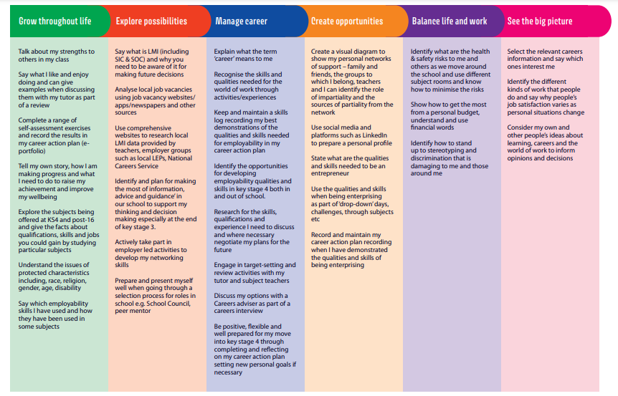
The careers provision and opportunities at Great Academy Ashton has been cross referenced to ensure that by the end of Key Stage 3 all students are able to meet the ‘I can’ statements as prescribed by the Career Development Institute;
As a student at GAA I can…

Year 10
Students should be able to
- Know about the information advice and guidance available to them and how to access appropriate support
- To further develop employability skills
- To research, secure and take full advantage of any opportunities for work experience
- Understand the range of opportunities that are available to them for career progression, including in education, training and employment
- Identify their own strengths, interests, skills and qualities and be able to identify where they can develop these for future employment
- Understand different work roles and career pathways including clarifying their own early aspirations
- All CEIAG activities recorded on Compass+.
- Home learning to complete linked specifically to CEIAG
- Development of their employability skills in all lessons and specifically through the use of SkillsBuilder Partnership
- Encounters with employers and employees through Work Safari trips to workplaces, assemblies, workshops and visitors
- Development of their enterprise skills through applied learning opportunities
- Signposting to literature, websites, social media and platforms which will help develop CEAIG
- Participate in National Careers, Apprenticeship, Science and My Money week year group activities
- Go Further and employer mentoring schemes for select students
- Higher Education and University workshops
- Student voice activity to evaluate and improve the CEIAG at GAA

1 | LMI what is - introduction to 2 sectors
2 | Pre-careers fair work/post careers fair lesson - making it meaningful.
3 | How to write a CV, statement of application and fill in an application form - how to spend your time wisely to add stuff to your CV
4 | Life beyond KS5 - Lifelong learning.  Post 18 and adult education
5 | The range employment types and different workplaces what it is like to work there.
6 | What is KS5 - range of opportunities available - introduction to qualification levels/types
7 | Preparing for interviews - mock interview/college interview and 1:1 careers interview in Year 11
8 | Your enterprise journey 4

Year 11
Students should be able to
- Understand about employer rights and responsibilities at work
- Identify their own strengths, interests, skills and qualities and be able to identify where they can develop these for future employment
- Understand different work roles and career pathways including clarifying their own early aspirations
- All CEIAG activities recorded on Compass+.
- Home learning to complete linked specifically to CEIAG
- Development of their employability skills in all lessons
- Encounters with employers and employees through Work Safari trips to workplaces, assemblies, workshops and visitors
- Development of their enterprise skills through applied learning opportunities
- Signposting to literature, websites, social media and platforms which will help develop CEAIG
- Participate in National Careers, Apprenticeship, Science and My Money week year group activities
- Go Further and employer mentoring schemes for select students
- Higher Education and University workshops
- Student voice activity to evaluate and improve the CEIAG at GAA

1 | Your future - the local offer - Tameside, Oldham and Manchester
2 | Qualification levels and types - what is a T level, pre T level, Apprenticeship, BTEC, A level - what is the local offer - across Greater Manchester. How to research and back plan to support your future plans .
3 | LMI - Manchester and Tameside what does the sector look like and where are the job opportunities - jobs of the future
4 | Pre-careers fair work/post careers fair lesson - making it meaningful.
5 | Know your rights and responsibilities as an employee
6 | Your online professional presence. LinkedIN, alumni and the importance of networking.
7 | Your future - the local offer - Tameside, Oldham and Manchester

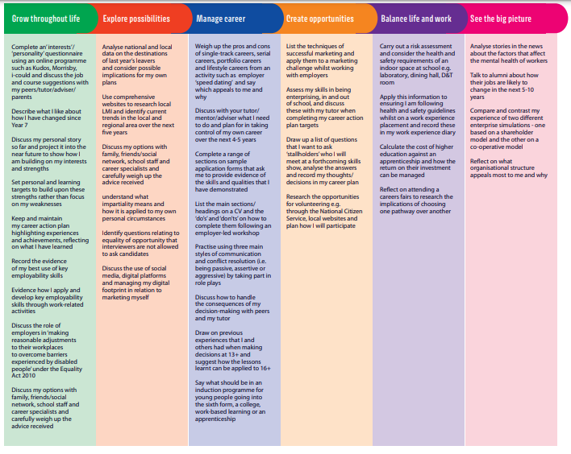
The careers provision and opportunities at Great Academy Ashton has been cross referenced to ensure that by the end of Key Stage 4 all students are able to meet the ‘I can’ statements as prescribed by the Career Development Institute;
As a student at GAA, I can…

