HOW TO LOG IN TO YOUR XELLO ACCOUNT
Xello is a useful website that can be used by GAA students to build their skills, knowledge and plans for future success. Students are able to build their self-knowledge, explore post-16 options, and create and amend career plans as they gain more experiences and re-assess their career aspirations.
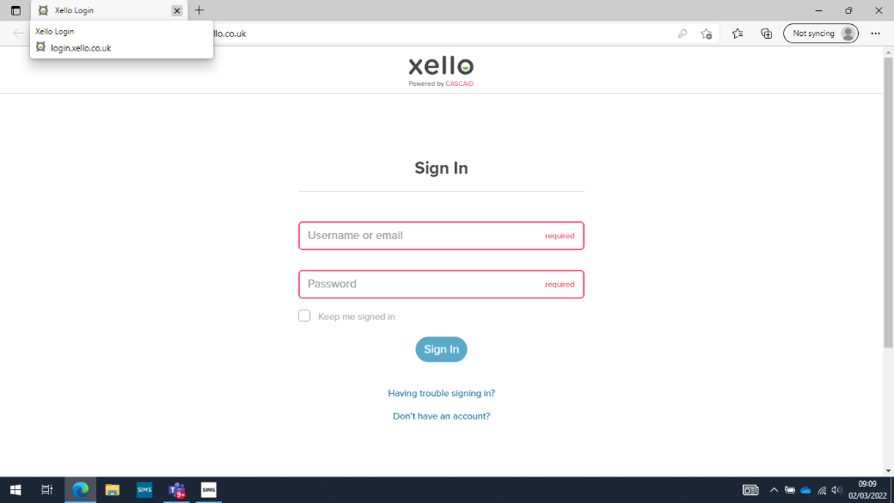
- Go to: https://login.xello.co.uk/

- Sign into your account.
Username/E-mail: This is your SCHOOL e-mail address
Password: This is your Date of Birth in the format DDMMYY
(If your date of birth is 3rd April 2015, the password would be 030415)

- Once you are in your account you can complete the ‘About Me’ activities, explore the Post-16 options and take part in any of the career based lessons to help inform your future.

