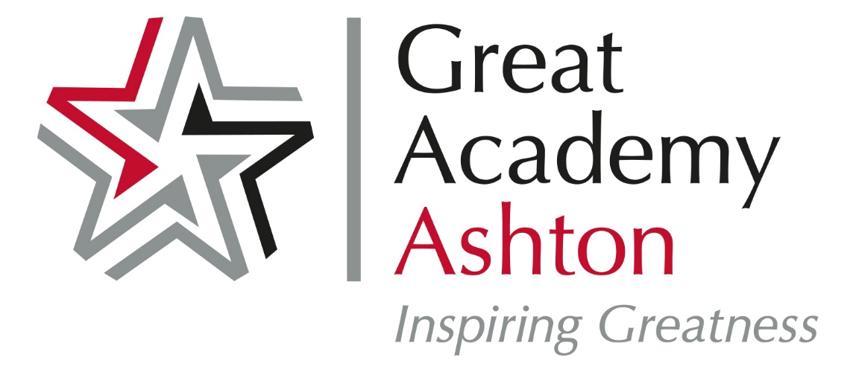
Recommended Reading for Year 7 Students at GAA
Reading for pleasure is an essential part of learning at Great Academy Ashton. Hopefully, many of you will already be enthusiastic readers, and will have your own favourite authors or types of story. Regular reading of challenging books (whether fiction or non-fiction) is not just enjoyable for its own sake, but also goes a long way towards improving many aspects of your English – breadth of vocabulary, spelling, punctuation, grammar – as well as strengthening your own writing skills. Reading will also benefit your other subjects, you will be expected to read and use subject specific vocabulary in all lessons in secondary school.
The following is a list of books, most of which are available in the school library. Many of them are recommended by GAA students past and present who have read and enjoyed them. You should keep this list; it is there to help you choose the books YOU want to read. The books on the Reading List have not been divided up into difficulty categories. This is because everyone reads at their own pace: some of you will enjoy a book like 'The Lord of the Rings’ in Year 7, while others may prefer to leave a book like this until Year 9. However, you should always be looking to challenge yourself with the books you read. This does not mean forcing you to read books you find boring, but neither does it mean that you should still be reading the kind of books at the end of a school year that you were at its start. For example, if you are a fan of horror fiction, you might have started off at Primary school on ‘Goosebumps’ books, progressing in Years 7 and 8 to Darren Shan titles, then by year 9 trying out some other good horror authors such as Stephen King, Clive Barker and Bram Stoker. The books on this reading list are a starting point; you will read many more than this, we are sure of that.
The Librarian and your teachers will be happy to suggest books for you to read – just ask. Hopefully, you will find new authors and genres which you find interesting. Above all, ENJOY your reading.
Books to read for Transition from Year 6 into Year 7
Who Let the Gods Out by Maz Evans – every new Year 7 student in September 2022 is being given this book, a fantastical story about Classical Gods. They are funny, wild, emotional and unpredictable; a bit like us humans – only with super powers!
His Dark Materials series by Philip Pullman – start with Northern Lights, where Lyra finds out there is an expedition to find other worlds. A highly recommended alternative reality series to get Y7 students hooked on reading at the start of secondary school.
The Girl who Speaks Bear by Sophie Anderson and Kathrin Honesta – an unusual girl has to flee her home and finds her true family along the way.
Railhead by Philip Reeve – set in the distant future, in which humanity travels the stars, a teenage thief is asked to steal a mysterious object.
Holes by Louis Sachar – sent in error to a juvenile correction centre, a teen boy discovers the wardens are using the boys for manual labour.
Books to read by the end of Year 7
Freedom (1783) by Catherine Johnson – An emotive and passionate story about slavery and one child’s experience.
Artichoke Hearts by Sita Brahmachari – A spectacular coming of age story where different cultures collide and combine.
Kick by Mitch Johnson – Budi lives in Jakarta and dreams of escaping poverty through football stardom; his dreams abruptly end when he finds himself owing money to a very dangerous man.
The Goldfish Boy by Lisa Thompson – Matthew struggles to cope in the outside world due to his anxiety and OCD. A great book to open discussion about feelings.
Peter Pan by JM Barrie – the timeless classic story of the boy who never grew up.
The Dark is Rising by Susan Cooper – Just prior to his 11th birthday, Will discovers he is the last person left with the power of the Old Ones, and his mission is to guard and Light and drive out the Dark. Superb book for readers who love fantasy and mystery.
Boy and Going Solo by Roald Dahl – the hilarious autobiographies of Roald Dahl
The Diary of a Young Girl – Anne Frank – written when she was 13-15 years old and living in hiding in Amsterdam, ‘one of the greatest books of the century’ - Guardian
A Wrinkle in Time by Madeline L’Engle – Charles’ father has disappeared and Charles sets out to find a wrinkle in time – a gateway to a parallel universe – to save him. The first in a series of novel for students interested in science.
Across the barricades by Joan Lingard – Kevin and Sade live in Belfast, a gritty story of religious divide and mistrust.
War Horse by Michael Morpurgo – a gripping story of the horrors of war, told from the perspective of Joey, a horse.
Stone Cold by Robert Swindells – a thrilling story of an intrepid undercover journalist determined to catch a serial killer.
The Cay by Theodore Taylor – when World War II breaks out, 12 year old Philip and his mother embark on a long voyage. The ship is torpedoed and Philip is blinded and left stranded on an island with a man names Timothy.
Hunger Hames by Suzanne Collins – Katniss vows to win a reality TV show where one person from each district must fight to the death. A more mature series of novels to Y7 to get hooked on.
Wonder by R.J. Palacio – Augie want to be like every other ten year old. Augie he looks different. Can he convince everyone he’s just like them inside?
The Seeing Stone by Kevin Crossley-Holland – The stories of a Young King Arthur are told in 100 short chapters.
Watership Down by Richard Adams – the well known animal adventure, a group of rabbits escape certain disaster as they search for a new home.
The Island at the End of Everything by Karen Milwood Hargrave – An atmospheric story about Amihan, who lives on an island affected by a leprosy outbreak. She finds allies in her quest to return home.
The Adventures of Huckleberry Finn by Mark Twain – Huck Finn and Tom Sawyer have made lots of money but all Huck wants is to escape his guardian.
The Lord of the Rings by J.R.R. Tolkein – an epic fantasy trilogy of novels, set in Middle-earth. A shy young hobbit inherits a simple ring.

For additional recommendations, updated termly, follow this link
Year 7 books for pupils aged 11-12 in KS3 - our suggested reads (schoolreadinglist.co.uk)

