Subject: Maths
Wider reading lists for students
Year group | Topic/module | Suggested reading
7 | Geometry: Introduction to the Pythagorean theorem | 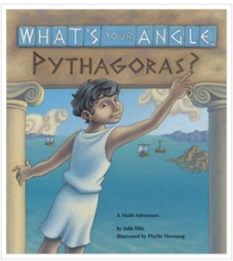  WHAT'S YOUR ANGLE, PYTHAGORAS?  Author: Julie Ellis  ​Illustrator: Phyllis Hornung
7 | Introduce or reinforce the concept of circumference, diameter and pi | 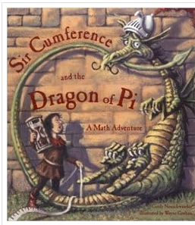  SIR CUMFERENCE AND THE DRAGON OF PI  Author: Cindy Neuschwander  ​Illustrator: Wayne Geehan
Year 7-9 | Maths in football | The Numbers Game: Why everything you know about football is wrong
Year 7-9 | Mostly number | Murderous Maths Book Series, by Kjartan Poskitt  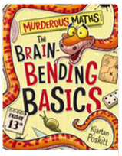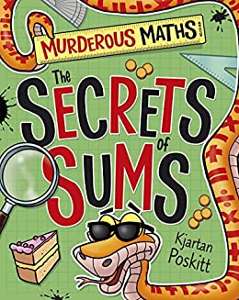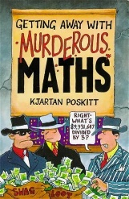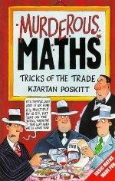
Year 7-9 | Number | The Number devil, by Hans Magnus
Year 7-9 | All Maths | Alice in Wonderland, by Lewis Carroll
Year 9-11 | Number | 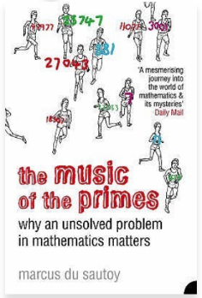  Marcus Du Sautoy – The Music of the Primes
Year 9-11 | Mathematical ideas | 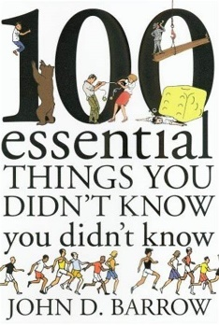  100 Essential things you didn’t know you didn’t know, by Jon D Barrow
Year 9-11 | Number | 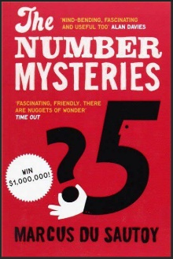  Marcus Du Sautoy –The Number Mysteries
Year 9-11 | Mathematics in general | 30-Second Maths: The 50 Most Mind-Expanding Theories In Mathematics, Each Explained In Half A Minute  by Richard J. Brown
Year 9-11 | Mathematics in general | 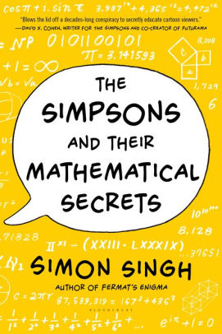  Simon Singh – The Simpsons and their Mathematical secrets
Year 9-11 | Infinity | Infinity: The Quest to Think the Unthinkable, by Brian Clegg
Year 9-11 | Zero | Zero: The Biography of a Dangerous Idea, by Charles Seife
Year 10 - 11 | Statistics | 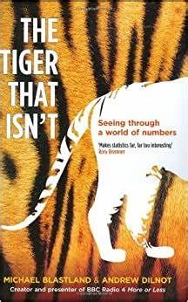  The Tiger that isn’t, by Michael Blastland and Andrew Dilnot
Y11 | Chaos Theory | Chaos; The Amazing Science of the Unpredictable, by James Gleick

