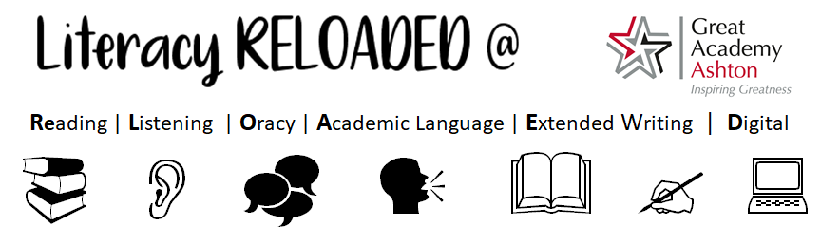Essential Academic Word List
KS3 Wider Academic Word List
KS4 Wider Academic Word List
At Great Academy Ashton, we have an academy wide focus on improving students’ ability to read, understand, speak and use academic and disciplinary language. Words can be classified into three tiers. High frequency words are tier 1; we use them all the time and students usually have good knowledge of these words. Tier 3 words are subject specific, for example ‘meander’ bend in a river, ‘evaporation’, ‘photosynthesis’ … these words are covered in key words in lessons and as such, students often understand and apply these words with confidence. It is tier 2 words, frequently used in written text but less commonly in speech, these words are proven to provide difficulty for students to understand.
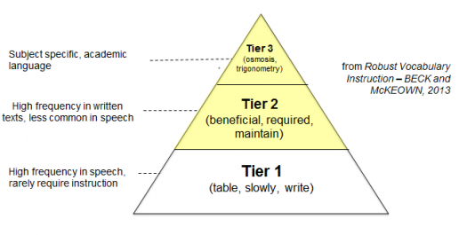

As such, the 51 essential words are all ‘tier 2’ words; in other words, they are seen as ‘academic vocabulary’ and if students know them, they can understand them and use them, students will be able to communicate more precisely and effectively in life. They are relevant to a wide range of subjects.
Students could:
- Read each word and its definition and then write one sentence in which to use that word. For example, “The number of trains put on for the football match was adequate in coping with the amount of extra passengers.”
- Make some cue cards with the word on one side and the definition on the other and use them to help learn the words
- Practise spelling each word

51 Essential Academic Words at GAA
- Adequate: satisfactory or acceptable in quantity or quality
- Adjacent: next to or adjoining something else
- Advocate: 1.a person who publicly supports or recommends a particular cause or policy. 2.a person who puts a case on someone else's behalf. 3.publicly recommend or support.
- Albeit: although, though
- Ambiguous: not clear or decided- open to interpretation –not having one clear meaning
- Analogy: a comparison between one thing and another, typically for the purpose of explanation or clarification.
- Articulate: 1. Having the ability to speak fluently and clearly 2. Having joints or jointed segments
- Assimilate: 1. To take on board and understand fully 2. To become absorbed into something else –a community, a society...etc.
- Attribute: 1. to explain something as being caused by something else. 2. a quality or feature regarded as belonging to someone or something.
- Authority: 1. the power or right to give orders, make decisions, and enforce obedience. 2. a person or organisation having political or administrative power and control.
- Benign: 1. gentle and kind. 2. (of a disease) not harmful in effect
- Conformity: to fit in with standards, rules or laws to behave in a way which is acceptable to society
- Consistent: acting or done in the same way over time, especially in a way to be fair to be unchanging over time to be in agreement with something
- Context: the circumstances that form the setting for an event, statement, or idea, and in terms of which it can be fully understood.
- Conventional: to base something on what is generally done or believed in someone who is very concerned (sometimes too concerned) with what is socially acceptable
- Culminate: to reach the most exciting part or point of greatest development to be the most exciting part or point of greatest development
- Decipher: to convert or change something into normal language to be able to understand something
- Diverse: showing a great deal of difference
- Eccentric: unconventional or slightly strange
- Era: long and distinct period of history
- Exemplify: be a typical example of, illustrate or clarify by giving an example.
- Facilitate: make (an action or process) easy or easier.
- Feasible: possible to do something easily or conveniently to be likely; to be probable
- Hierarchical: arranging something in order of rank or in order or importance
- Hindrance: a thing that provides obstruction or delay to something
- Ideology: a set of beliefs of an individual or a group, sometimes forming the basis of thinking or political policy
- Implicit: 1. Suggested but not deliberately said. 2. Always connected with3.Something that someone feels without question
- Implications: 1. A likely consequence of something 2. Conclusion that can be drawn from something, although not one that is openly stated
- Imperative: 1. Of vital importance; crucial2.Giving a command
- Indifferent: having no particular interest in or view on something, something that is neither good or bad
- Inherent: existing within something as a permanent quality
- Inferred: to work something out / to conclude something from evidence, rather than from things directly stated
- Insinuate: 1. suggest or hint (something bad) in an indirect and unpleasant way; 2.to carefully manoeuvre oneself into a favourable position
- Integrity: the quality of being honest and having strong moral principles, the state of being whole / not being divided
- Justification: the act of showing something to be right there being good reason for something that exists or has been done
- Perspective: a particular attitude towards something or view of something, the appearance of something, from the viewpoint of someone who is looking at it
- Phenomenon: 1. A remarkable person or thing; 2. A fact or situation which is observed to happen, especially one where the causes aren’t clear or could be debated
- Pivotal: of crucial importance to the success of something else; fixed on, or as if on a pivot
- Plausible: 1. Something that seems reasonable or probable; 2. Someone who is good at producing good arguments, especially those which are designed to achieve
- Predominant: 1. The strongest or main element; 2. Having control or power
- Proficient: competent or skilled in doing or using something.
- Renounce: to formally reject something; to refuse to continue to support something
- Significant: 1. Having a particular meaning 2. Important enough to be worthy or attention
- Stability: 1. The state of being stable –of not being easily upset or disturbed; 2. Not likely to change or fail –to be firmly established
- Subsequent: coming after something in turn; following something
- Sufficient: enough / adequate
- Trivial: of little value of important; someone concerned with unimportant things
- Turbulent: something violent or unsteady; being in a state of conflict or confusion
- Validity: something that has a sound basis in logic; the quality of being logically sound; something being legally binding
- Vice versa: when the things that have just been mentioned are turned the other way around
- Voracious: wanting or eating large quantities of food; doing something with lots of enthusiasm
Follow this link to access more academic words, these are generic academic words and families of words, these are the most common words used in academic texts.
EAP Vocabulary (uefap.com)

In addition to these 51 essential academic words you must know, we have a separate list of KS3 and KS4 word lists at Great Academy Ashton. These words are sorted by difficulty (at KS3 Bronze, Silver and Gold. Silver and Gold at KS4), you will find the 51 essential words within these lists. During form time students are given a selection of these words to learn for a quiz the next week. GREAT points are awarded to the best performing students and forms each year. Further to this, once a week, we focus on the etymology, morphology and phonology of selected words to give students a deeper understanding of how words gain their meaning, change with use and link to other words.
There are many things students can do themselves to improve their vocabulary but the most important of these is to do independent reading, especially of books which they might find challenging. Just 20 minutes or so of reading a day can make a remarkable difference. An especially helpful resource for looking up new words is https://www.lexico.com/. Not only does it include the definitions of a word but it also explains its origins and gives example phrases which use that word. We encourage every child to borrow a book from Our Library. Until Our Library opens, all students have access to Sign In - myON® where they can access an online catalogue of over 6300 books.
KS3: Wider Academic Word List
Bronze |  | Silver |  | Gold
ability | explain | abuse | estimate | acceptance | expand
absorb | filter | accelerate | evidence | access | factor
accident | framework | accuracy | explicit | adapt | finance
advantage | function | adjacent | features | alien | flashpoint
alternative | goal | advertising | formal | alignment | fund
appropriate | guidelines | annual | fundamental | analyse | generation
arrange | hence | appreciating | grant | antagonist | heritage
authority | identify | ascending | humility | apparent | immigrate
balanced | illegal/legal | associate | hypocrite | assertive | implicate
benefits | illustrate | attitude | implement | bias | in/finite
caption | independent | attribute | impose | capacity | influence
combinations | label | collaboration | inevitable | characteristic | internal
comment | layer | collage | initial | code | macro
commit | link | communicate | instance | communities | maximise
complex | modify | compare | interact | compatibility | negate
concept | obvious | competition | interpret | component | original
conduct | option | concentrate | justify | confer | phase
conflict | outcome | conclude | locate | confidence | philosophy
consequence | outline | conscious | machine | conformity | physical
constant | overall | contemporary | minor | consumer | prior
core | partner | contradict | occupy | contrast | profit
create | primary | contribute | opinions | convert | proportion
crime | project | criteria | parallel | coordinate | publish
current | quote | culture | peer | correspond | qualities
decade | react | cycle | portray | critical | reference
define | remove | debate | potential | data | relevant
descending | simplify | demonstrate | principal | deficiency | research
describe | sum | despite | professional | detection | retain
design | task | determine | promote | develop | scheme
direct |  | dimension | Register | Distinct | society
dominate |  | efficiency | Rely | Economic | status
ensure |  | emphasis | series | emerge | subsequent
equipment |  | enhance | shift | equate | summary
error |  | era | source | equivalent | undertake
 |  |  | statistic | exclude

KS4: Wider Academic Word List
Silver |  |  | Gold
abnormalities | context | motive | abstraction | conventional | norm
accumulation | controversy | opaque | aesthetically | deduce | objective
adequate | conviction | perception | allusion | degenerative | oppression
ambiguous | corporate | political | apprehension | dependent | parameter
annotation | cross-section | proactive | arbitrary | disclosure | perspective
anxiety | deduce | protagonist | assumptions | discriminate | resolve
approximate | deposit | rational | catalyst | disperse | state/nation
assess | deterrent | realistic | circumstance | equivocal | stigma
chronological | domestic | reflect | civil | estimate | substance
closed questions | embody | regime | classical | generate | sufficient
coercion | equilibrium | rigorous | classification | hypothesis | sustain
coherent | evaluate | specify | composition | inherent | technique
commutative | exclusive | technology | conditional | innate | theory
compensate | hierarchy | tradition | conjecture | integrate | valid
confidential | icon | urban | connotation | intuitive | wealth
consent | ideology | utilise | consistently | legislate | whimsical
considerable | imply | virtual | contingencies | liberal | zenith
constrain | impulsive |  | continuity | logical
contagious | media |  | convene | motif

