Summer School GAA 2020-21 Impact Report.
The purpose of the Great Academy Ashton Summer School
Department for Education (DfE) research estimates that in the first half-term of autumn 2020, pupils in:
- year 3 to 9 were on average around 1.6 to 2 months behind on their reading.
- year 3 to 7 were around 3.2 months behind on their maths.
Schools with high numbers of pupils eligible for free school meals were on average further behind those in schools with low free school meals eligibility. This is a particularly key aspect for Great Academy Ashton as presently 45.6% of our students benefit from the Pupil Premium grant.
Additional evidence also points to children and young people’s mental health having suffered from lockdown and from periods of individual or class isolation after schools reopened fully in the autumn term.
Summer school provision with an academic focus has the potential to support attending pupils to make up for some of their missed education. The Education Endowment Foundation (EEF) finds that, on average, pupils attending a summer school can make:
- 2 months’ additional progress (compared with pupils who do not attend)
- up to 4 months’ additional progress if the summer school offers small group tuition led by highly-trained and experienced teaching staff.
Evidence suggests a broader benefit for families and communities, support for vulnerable children and young people, pupil mental health and wellbeing, improved education engagement and transitions, and reduced youth violence.
Great Academy Ashton Summer School 2021
Key target areas of support:
- Academic support
- Social and Emotional Health and Wellbeing
- Sense of belonging and transition bridging
Academic Support:
Catch up from year 6 in core subject areas and bridging transition units in the following core subject areas:
- English
- Maths
- Science
Social & Emotional Mental Health and Well-being:
To address and support social emotional, health and wellbeing issues, form and develop friendships with peers and establish relationships with key academy staff members.
Key transition information shared by our feeder primary schools was used to identify the needs of our most vulnerable students. Support took place on 1:1 and small groups. Records of meetings and all documentation is stored with the pastoral teams and shared with appropriate individuals. Provision was established in order to support students both proactively and in response to their specific needs when they arose. Early interventions were established, additional parental/carer meetings held and individual support transition plans put in place.

Sense of belonging and transition building:
Due to CV19 pandemic scheduled open days and transition days could not take place on site and was delivered on-line. The summer school gave us the ability to invite our upcoming intake on site to familiarise themselves with our Academy.
- Team Building and Problem solving, maximising student engagement participation and celebration.
- Introduce and embed the GAA expectations and GREAT Values.
The Summer School at GAA:
Run across 10 school days. Each placement was 5 consecutive days. Each student that was invited was entitled to 5 days of Summer School activities based around curriculum experiences in English, Maths and Science, delivered by GAA subject specialists.
A wide range of sporting, arts crafts and personal development activities supported by the Military (Army Schools Engagement Team) and Manchester United Foundation.
Programme of events
 | Monday | Tuesday | Wednesday | Thursday | Friday
9.30am | Arrive and registration | Arrive and registration | Arrive and registration | Arrive and registration | Arrive and registration
9.40am+ | Academy Tour | Group 1: English Topic Based Activity led by SHE Group 2: Maths Topic Based Activity led by JAD Group 3: Science Topic Based Activity led by NBU | Group 2: English Topic Based Activity led by SHE Group 3: Maths Topic Based Activity led by JAD Group 1: Science Topic Based Activity led by NBU | Group 3: English Topic Based Activity led by SHE Group 1: Maths Topic Based Activity led by JAD Group 2: Science Topic Based Activity led by NBU | Old Trafford Visit or trip out with Packed Lunch Staffing for the Man Utd Trip JPI & SHE
1030am - 12.00pm | Socially distanced team building activities and getting to know you games
12.00pm | Lunch | Lunch | Lunch | Lunch
12.30pm - 2.00pm | Manchester United Foundation Enrichment | Manchester United Foundation Enrichment | Manchester United Foundation Enrichment | Manchester United Foundation Enrichment
Staffing = 6 x Teaching Staff; 3 x Support Staff

Student Feedback from GAA Summer School
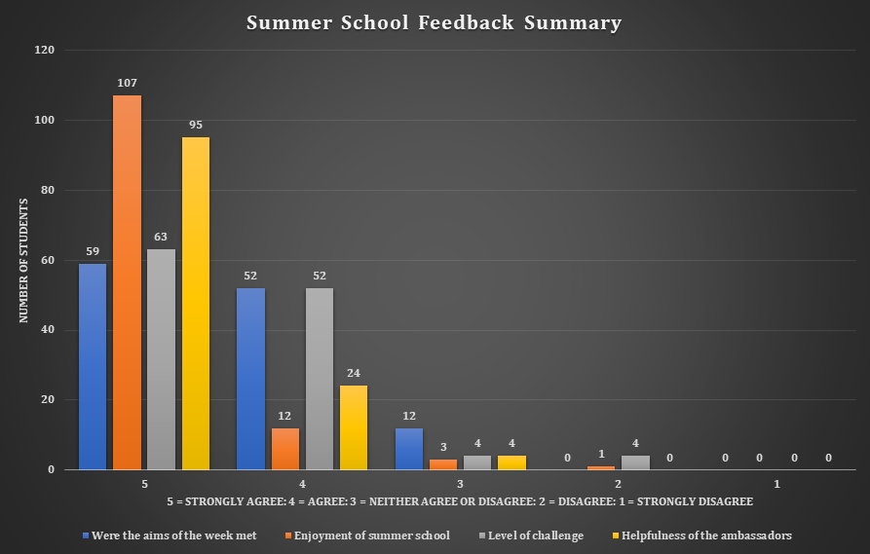

Student Participation:
Day | Day 1 | Day 2 | Day 3 | Day 4 | Day 5 | Day 6 | Day 7 | Day 8 | Day 9 | Day 10
Number of Students attending. | 78 | 82 | 82 | 82 | 81 | 76 | 82 | 81 | 79 | 82
Total Number of Students |  |  |  |  | 164
Total Number of students Not eligible for Pupil Premium Funding who attended |  |  |  |  | 94 (57.3%)
Total Number of students eligible for Pupil Premium Funding who attended. |  |  |  |  | 70 (42.7%

Teaching Staff | Support Staff
Mr S. Kennerley- Summer School Lead  Mrs S. Wrigley- Head of Year  Miss A. Hadfield- Team Building/Crafts/Sports  Mr J.Aderbewole- Maths Lead  Miss S Paddison- Science Lead  Mr S.Hewitt- English Lead | Miss S. Kennedy- Registers/Admin/ support with Team Building  Mrs J. Pilling-Support/Mentor/Attendance/Wellbeing  Mr R.Monk- Manchester United Foundation/Enrichment Organiser.

Summer School Spending
Staffing and Costs Incurred | £13,125.00

Student quotes based on their experiences:
- ‘I have made lots of friends and got to know the school and teaching staff of GAA.’
- ‘I love the quality of the school.’
- ‘I will be looking forward to joining this school and all the teachers are cool. Can’t wait!!’
- ‘I had lots of fun and I hope I can do it again’.
- ‘I really enjoyed summer school (even though it was challenging) and I am happy I did it’.
- ‘I really loved the summer school and enjoyed writing a letter to Marcus Rashford’.
- ‘I loved all the sports and the science, and the art was fun’.
Parent comments:
- ‘Thank you for doing the summer school as it really has helped my child with looking forward to starting in September as I know he was very nervous. He has loved every part of the experience’.
- ‘Summer school has made my daughter less nervous about starting in September which also makes me less worried for her. She has also made some new friends from other schools’.
- ‘Huge thanks to all of the staff for providing this experience. My daughter has really enjoyed it and feels much more positive about starting in September5’.
- ‘I believe that this week has given my son an insight on what to expect when he starts secondary school in September, and he is excited and can’t wait’.
- ‘Thank you for all the support during transition. We were reluctant to accept the place initially, but with all the opportunities my daughter has had during the transition period, we feel confident that it is the school for her’.
Summary and moving forwards:
- The students, staff and parents are clear in their opinions that the summer school programme at GAA was successful and achieved its aims of supporting Y7 transition both academically and in terms of social, emotional & mental wellbeing.
- The curriculum was varied and successfully captured students’ imaginations, whilst also providing them with a sound introduction to our routines and expectations.
- The assemblies that took place helped ensure the GAA ‘GREAT Values’ Culture and ethos were introduced early to our rising Year 7s. Team building activities and visits to Old Trafford helped to create a sense of community, celebration and participation and ensured the students left with a clear understanding of the wider GAA school community and activities on offer.
- If finances permit, there is a strong argument for repeating the summer school in summer 2022 on a larger scale. The structure of the day worked well and could be replicated without change.
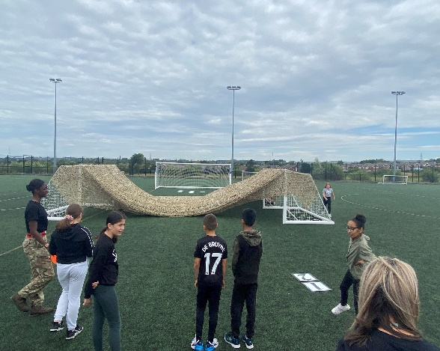
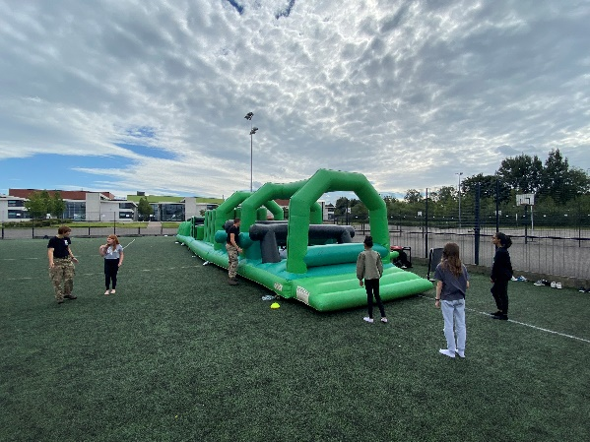
- Attendance at the summer school (62% of the Year 7 Cohort) This could potentially reach even higher if the dates were published to rising Year 7 parents earlier, and potentially if the summer school took place either the first or last week of the summer holiday. A few parents responded to the initial summer school invitation saying they would have liked their child to attend but had pre-arranged holidays. The summer school has certainly help to establish a positive start to secondary school for year 7 with daily attendance figures well above National Averages.

