GCSE French (AQA: 8658)
Pupil Overview

Contents
Introduction – Why GCSE French? 2
Themes 2
Grammar 4
Skill Elements 5
The Speaking Exam (25% of overall grade) 5
Top tips for the speaking exam! 5
The Reading Exam (25% of overall grade) 5
Top tips for the reading exam! 6
The listening exam (25% of overall grade) 6
Top Tips for the listening exam! 6
The writing exam (25% of overall grade) 7
Top tips for the writing exam! 7
Key Vocabulary 8
Revision tips and techniques! 8

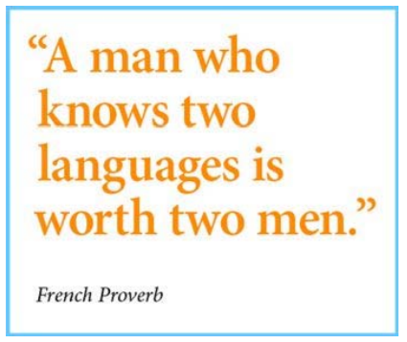
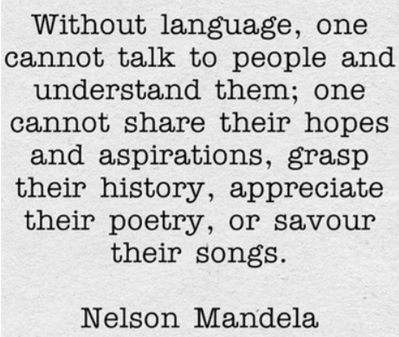
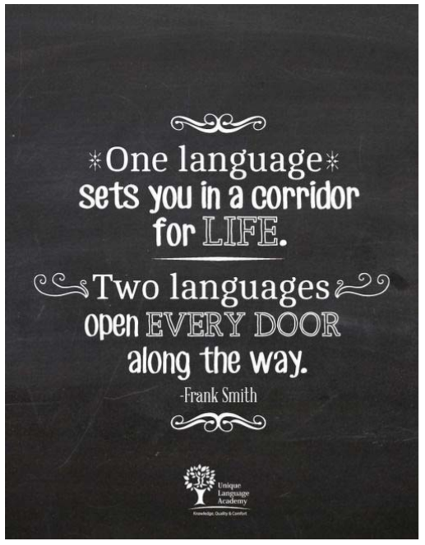
Acknowledgement: Thanks to Park Hill Academy for sharing their booklet which I have slightly adapted. H E Myers November 2018.
“Those who know nothing of foreign languages know nothing of their own.”
Johann Wolfgang von Goethe

Introduction – Why GCSE French?
Well done for making a fantastic choice! This booklet will talk you through the important elements of the course and all of the key information you need to know!

Taking a language is more important than ever in today’s multi-cultural society and many businesses, colleges and universities will snap you up if you have a qualification in a language!
French a really useful language for many different jobs including teaching, translation, fashion and journalism alongside many others!

Use this booklet to help support you with the course and work hard. It will be hard work but
if you put in 100% you will do well!

Themes
The course is split into different ‘Themes’ and within these themes there are different topics and subtopics. Although you will be studying different themes and topics as you progress through the text book, it is important to keep revising all work you have done before so you don’t forget it! Your teacher will help you to do this with different activities and tests within lessons.

The specification is online here: https://filestore.aqa.org.uk/resources/french/specifications/AQA-8658-SP-2016.PDF

The themes apply to all four question papers. You are expected to understand and provide information and opinions about these themes relating to your own experiences and those of other people, including people in countries/communities where French is spoken.

Theme 1: Identity and culture
Topic 1: Me, my family and friends
• Relationships with family and friends
• Marriage/partnership
Topic 2: Technology in everyday life
• Social media
• Mobile technology
Topic 3: Free-time activities
• Music
• Cinema and TV
• Food and eating out
• Sport
Topic 4: Customs and festivals in French-speaking countries/communities

Theme 2: Local, national, international and global areas of interest
Topic 1: Home, town, neighbourhood and region
Topic 2: Social issues
• Charity/voluntary work
• Healthy/unhealthy living
Topic 3: Global issues
• The environment
• Poverty/homelessness
Topic 4: Travel and tourism

Theme 3: Current and future study and employment
Topic 1: My studies
Topic 2: Life at school/college
Topic 3: Education post-16
Topic 4: Jobs, career choices and ambition

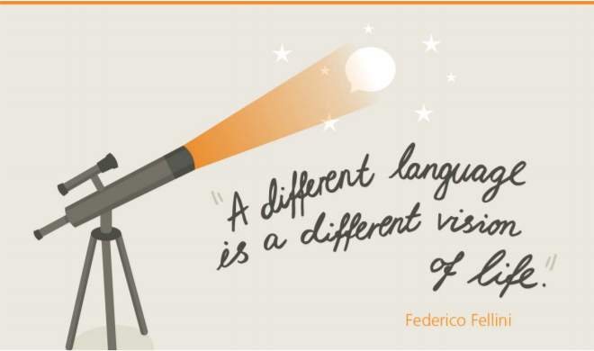

Grammar
Here is the grammar expected as issued in the exam specification. (Higher in bold)

Nouns
gender
singular and plural forms
Articles
definite, indefinite and partitive, including use of de after negatives
Adjectives
agreement
position
comparative and superlative: regular and meilleur
demonstrative (ce, cet, cette, ces)
indefinite (chaque, quelque)
possessive
interrogative (quel, quelle)
comparative and superlative, including meilleur, pire
Adverbs
comparative and superlative
regular
interrogative (comment, quand)
adverbs of time and place (aujourd’hui, demain, ici, là-bas)
common adverbial phrases
comparative and superlative, including mieux, le mieux
Quantifiers/intensifiers
très, assez, beaucoup, peu, trop
Pronouns
personal: all subjects, including on
reflexive
relative: qui
relative: que (R)
object: direct (R) and indirect (R)
position and order of object pronouns (R)
disjunctive/emphatic
demonstrative (ça, cela)
indefinite (quelqu’un)
interrogative (qui, que)
use of y, en (R)
use of y, en
relative: que
object: direct and indirect
position and order of object pronouns
demonstrative (celui) (R)
possessive (le mien) (R)
relative: dont (R)

Verbs
regular and irregular verbs, including reflexive verbs
all persons of the verb, singular and plural
negative forms
interrogative forms
modes of address: tu, vous
impersonal verbs (il faut)
verbs followed by an infinitive, with or without a preposition
Tenses:
•• present
•• perfect
•• imperfect: avoir, être and faire
•• other common verbs in the imperfect tense (R)
•• immediate future
•• future (R)
•• conditional: vouloir and aimer
•• pluperfect (R)
•• passive voice: present tense (R)
•• imperative
•• present participle.
•• future
•• imperfect
•• conditional
•• pluperfect
•• passive voice: future, imperfect and perfect tenses (R)
•• perfect infinitive
•• present participle, including use after en
•• subjunctive mood: present, in commonly used expressions (R)
Prepositions
common prepositions eg à, au, à l', à la, aux; de, du, de l', de la, des; après; avant; avec; chez; contre;
dans; depuis; derrière; devant; entre; pendant; pour; sans; sur; sous; vers
common compound prepositions eg à côté de; près de; en face de, à cause de; au lieu de
Conjunctions
common coordinating conjunctions eg car; donc; ensuite; et; mais; ou, ou bien, puis
common subordinating conjunctions eg comme; lorsque; parce que; puisque; quand; que; si
Number, quantity, dates and time
including use of depuis with present tense
including use of depuis with imperfect tense.

Skill Elements
The final exams for this course will be in the summer term of year 11.
You will be examined in four areas:
1. Reading and translation to English.
2. Writing and translation to French.
3. Listening
4. Speaking.

Each exam is worth 25% of your final mark and you will be graded from 9-1 (1 being the lowest
and 9 being the highest).
You won’t sit all of your papers at the same time; your speaking exam will be a couple of
weeks before the others.

The Speaking Exam (25% of overall grade)

There are three parts to your speaking exam and this will be conducted by your teacher.
It will be recorded and then sent off to the exam board to check the marks.
Before you start, you will get 12 minutes to prepare for the first two sections of the
exam. You are not able to keep these notes for the third part of the exam.

Part One: Role Play (2 mins.)
You will get a card with a scenario on it, it will have five bullet points on it. Three of these
will be notes on what to say in French, !means you will be asked an unknown question
and ? means you have to ask a question about the words next to it. The role play
will tell you if you must use tu but otherwise use vous.

Part Two: Photo Card (3 mins.)
Before the exam you will receive a photo card and three questions about it. You will be
asked these three questions plus two more that you haven’t seen before.

Part Three: Conversation (5-7 mins.)
You and your teacher will have a conversation, in French. The conversation will be based on
the theme that you have chosen and the other theme that hasn’t been covered on
the photo card. You are expected to ask your teacher one question.

Top tips for the speaking exam!
- Know the marking criteria for each element [See separate booklet]
- Use your full range of language (tenses/talking about others/opinions and reasons).
- If you’re unsure of a word you want to use, replace it with another you know, e.g. swap
snooker for hockey or nephew for brother.
- If you are really struggling ask for help (in French). You won’t get any marks for any
- vocabulary you are given but it will help you to develop your work.

The Reading Exam (25% of overall grade)
You will either take higher or foundation in the reading exam. If you take higher your paper will
be one hour long and you have access to the higher grades 9-4. If you are sitting foundation,
your paper will be 45 minutes long and you will have access to the grades 5-1.

The reading exam will be split into three parts.

Section A: comprehension in English about French texts.
You will be given a selection of texts in French and asked questions about them in English. For
this part of the paper you should answer in English.

Section B: comprehension in French about French texts.
This section will be a little more difficult as the texts and the questions will be in French but if
you revise all the key question words you shouldn’t have a problem!

Section C: Translation from French to English.
Here, you will be given a short passage in French which you will be expected to translate
to English without a dictionary. You need to make sure you translate all of this text as you
get marks for each bit you do accurately.

Top tips for the reading exam!
- Read the questions very carefully – what is it asking you to do?
- Don’t give up if you don’t understand something. Use the context to help you! Are there any cognates?
- Keep an eye on the time – there is lots to do so go at a decent speed! If you’re having trouble with a question go back to it later.
- The translation is worth the most marks on the paper so make sure you leave plenty of time to tackle it!
- Make sure you answer every question. Many questions are multiple choice so if you are unsure have an educated guess!
- Before you begin to translate, read the whole text and get the gist of what it is saying.
- Translate one sentence at a time and look back to check it makes sense!
- Look out for time indicators (hier/demain/le weekend) which might suggest a change in tense.

The listening exam (25% of overall grade)
You will either take higher or foundation in the listening exam. If you take higher your paper will be 45 minutes long and you have access to grades 9-4. If you are sitting foundation, your paper will be slightly shorter and you will have access to the grades 5-1.

The listening exam is split into two sections.

Section A: French listening to English answers.
You will hear a range of spoken French and will answer questions in English about what you have heard.

Section B: French listening to French questions.
You will hear a range of spoken French and will answer questions in French about what you have heard.

Top Tips for the listening exam!
- You have five minutes reading time at the start of the exam. Use this to read through the
- paper and work out what you are being asked to do. In particular, the questions in section B which are in French.
- Make notes whilst you are listening to the recording, you will hear each track twice with a pause in between.
- Listen right to the end, even if you think you have the answer. Sometimes the person will change their mind!
- Don’t panic if you do not understand everything. Listen carefully and pick out the vocabulary you need to answer that particular question.

The writing exam (25% of overall grade)
You will either take higher or foundation in the writing exam. If you take higher your paper will be 1 hour 20 minutes long (5 minutes extra for 2021) and you have access to the higher grades. If you are sitting foundation, your paper will be 1 hour 5 minutes (5 minutes extra for 2021) and you will have access to the grades 5-1.

The writing exam will be split into different questions with each question being worth a different number of marks. Make sure you spend more time on the higher mark questions.

FOUNDATION

Q1: Photo question. - Write 4 sentences to describe a photo [8 marks]
'Qu'est-ce qu'il y a sur la photo? Ecrivez quatre phrases en anglais'
Tip: Keep it very simple. You can start each sentence with 'il y a' (there is) and complete it with a noun. e.g. 'Il y a un homme. Il y a une fille. Il y a deux femmes. Il y a trois enfants.'

Q2: 40-word question - develop 4 bullet points into sentences.[16 marks]
Tip: keep it simple. You can use one tense.

Q3: Translation - 5 sentences including 1 past, 1 future [10 marks]

FOUNDATION '/ HIGHER OVERLAP

Q4: Q1 90-word question.[16 marks]

Here, you will have three (for 2021) tasks to choose from, each form a different theme. You will be asked to write about 90 words in French based on four bullet points. You must include information on each bullet point and give opinions. Always includes 1 past and 1 future sentence.
Tip: Keep it simple. Aim for 2 sentences per bullet point.

Q2 150-word question (32 marks)
Here, again, you will have three (for 2021) tasks to choose from. You will need to write about 150 words in French based on two bullet points. You have much more creative license here so show off!

Q3: Translation (12 marks)
Here, you will be given an English text which you must translate into French without a dictionary. Make sure you have translated everything from the text – you’ll lose marks if you miss anything!

Top tips for the writing exam!
- Know the marking criteria for each element [See separate booklet]
- Read through all instructions thoroughly and spend time planning,
- Tick off the bullet points as you go – use them as a check list,
- Write the best answer you can using the French you know – it doesn’t matter if it isn’t true (no-one will check!!!).
- Check your work thoroughly. Even small mistakes can cost marks! Look at verb endings, tenses, adjectives and tenses.
- For translations, read the whole text first so you know what it is about.
- Don’t translate things literally, check word order and other tricky French language patterns!
- Once you are happy with it, go back through and check you have included everything from the original text.

Key Vocabulary
Without knowing the basic vocabulary expected of you it is impossible for you to
pass the exam. Spend time learning vocabulary regularly alongside your homework to take the
pressure off at the end of the course!

Your teacher will have given you a vocabulary book with all the main words you need to know, you have a good text book which has vocabulary lists and a glossary at the back, and you can use various online programs such as Vocab Express and Quizlet.

Alongside topic vocabulary, make sure you know command words and question words such as the ones on the next page. You will not be able to answer questions written in French without them.

Le français | L’anglais
Décrivez | Describe
Ecrivez | Write
Ecrivez environ 40 mots en français. | Write about 40 words in French
Ecrivez environ 90 mots en français. | Write about 90 words in French
Répondez à chaque aspect de la question. | Respond to each aspect of the question.
Ecrivez environ 150 mots en français. | Write about 150 words in French.
Répondez aux deux aspects de la question. | Respond to both aspects of the question.
Mentionnez | Mention
Combien ? | How many ?
Comment ? | How ?
Est-ce que ? | Is it that / was it that / will it be that
Où ? | Where ?
Quand ? | When ?
Pourquoi ? | Why ?
Que ? | What ?
Quel/quelle ? | Which ?
Qu’est-ce que ? | What ?
Q u’est-ce qui ? | What ?
Qu’est-ce c’est ? | What is it ?
Qui ? | Who ?
Quoi ? | What ?

Revision tips and techniques!

Make sure you revise regularly so that the knowledge you need is embedded from early in the
course. This will mean that when you come to your exams you won’t be panicking and will have a chance to revise rather than re-learn.

Here are some tips which can work really well with French revision!
1. Be organised! Make a plan and make sure you cover everything on the specification.
2. Vocabulary: Put the topic title in the middle of the page and see how much you can remember. Go back through this and group the words into nouns, adjectives verbs etc.
3. Grammar: Don’t be scared of grammar, you know it and how to use it! Look back through each topic and go through the different grammatical aspects. Ask your teacher to go through things with you that you don’t understand. 'Thisislanguage' has excellent grammar tutorials.
4. Adapt: Adapt your knowledge. Could your reasons go across more than one topic? For grammar revision, choose a verb and see how many tenses you can put it in,
5. Choose: Choose a paragraph from your book or a textbook. How many different grammatical features (tenses/adjectives/nouns etc.) can you pick out?
6. Listen: Regularly to French people speaking. Tune into a French radio station or put your favourite film into French when you watch it. http://www.listenlive.eu/france.html
7. Speak: The more you do it the less scary it will be and the better you will become!
8. Practise – it makes (almost!) perfect!

