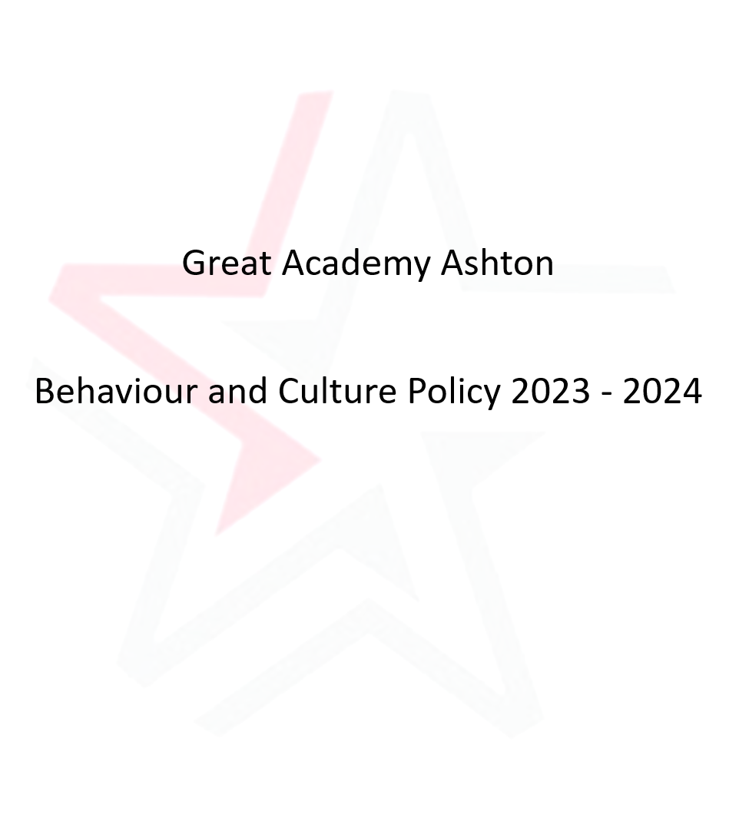

This document is written in conjunction with the Great Academy Education Trust Positive Behaviour Policy which is available on the GAET Trust Website and the GAA Website
At Great Academy Ashton, our purpose is inspiring Greatness. We focus on being the best version of ourselves to change our world for the better.
Great Academy Ashton is committed to ensuring that every student within our school community has the opportunity and support to:
- Achieve their full potential. GAA is committed to providing every student with the knowledge, skills and understanding that will enable them to flourish in and out of the classroom so that every student is able to move onto university, or a real alternative and then choose the career they want, that will help them to change our world for the better.
We believe the foundation to success is hard work and we have the highest expectations for every member of our school community, each and every day. Every single young person in our care has the responsibility for making GAA a truly GREAT place and we want all our students to use their time at the school to prepare themselves fully to be outstanding young people of our world.
Our purpose is greatness at GAA and we live our GREAT values in our actions.
Genuine – We are honest, trustworthy and take responsibility for our actions. We are proud to be a member of GAA we treat everyone with respect.
Respect – We use good manners and we treat everyone fairly and with kindness. We strive for excellence.
Excellence – We are the best version of ourselves and have high expectations of each other. We work hard and respond positively to all challenges. We aim to achieve.
Achieve – We strive to fulfil our highest potential and we participate fully in Academy life together.
Together – We are supportive of each other and celebrate our differences. We resolve any differences calmly, learning from them.
Together we are Great Academy Ashton
Consistency is key to success. At GAA our daily practice is not only supported by our GREAT values but also by our learning routines. In every classroom we expect that 100% of our students are on task 100% of the time. The routines for learning help to support every student’s progress:
• Threshold at the start and end of lessons.
• Do Now – students complete work in silence as soon as they enter your lesson
• Track the Speaker and Active Listening
• Directed Questioning (No Opt Out).
• Learning Modes (Silent Independent Study, Quiet Partners, Respectful Whole Class, Polite Table Group).
From the first day at GAA, students are expected to demonstrate our GREAT values through their daily actions both in and out of school.
We have high expectations and accept no excuses. Whilst sometimes this may be challenging, we expect our students to live by our GREAT values 100% of the time. If they do this, their hard work will be recognised. However, if any of our GREAT values are not met, a same-day correction will be issued. It is vital that this is served on the same day so that the student is given the opportunity to reflect on their mistake. This allows the student to take the necessary next steps to improve on the following day.

Aims
• To have the highest expectations of student behaviour and attendance so that every student can achieve their full potential.
• To ensure that every student develops into an outstanding young person that can have a successful life where they are the best possible version of themselves.
• To recognise realise and celebrate the potential of all students, thus promoting high self-esteem, high expectations and the ability to be economically successful.
• To create an environment in which students are enabled to become mature, self-disciplined and industrious, accepting responsibility for their own actions.
• To form an active partnership with parents and carers to support the learning of their children and to support them during any period of difficulty.
These aims are supported by regular and appropriate in-service training as well as staff CPD, close parental and community links, student organisation which takes account of ethnic and gender balance, the boosting of students’ self-esteem through positive reinforcement and extra-curricular activities, and Academy social events aimed at pulling together the different life experiences of groups within the community.

Recognition
We want students to be motivated by the intrinsic value of being the best version of themselves each day; however, we are committed to acknowledging students for developing good learning habits. Therefore, we have a reward and recognition system consisting of:
a.Student recognition
Each week, the Principal sends out postcards to students who have been nominated by Members of Staff. These postcards are addressed to the students and sent out in the post. Students may receive a postcard for repeatedly demonstrating our GREAT values, continued strong progress or for displaying a real commitment to the academy or the local community.
b. Verbal recognition and GREAT points
Around the academy, and in lessons, staff members use positive language and reinforcement to signal to students that they are demonstrating our GREAT values and following our routines for learning. GREAT points are given to students in and out of lessons to recognise their positive actions and students are presented with certificates to recognise when they have reached a particular GREAT point milestone.
c. Focussed Rewards
Each term students who have demonstrated continued exceptional conduct (such as zero corrections and 100% attendance) are invited to attend a special event led by their Head of year. Activities may include watching a film in the theatre with popcorn, an extended lunch break, sports activities or other fun alternatives.
d. Great values recognition scheme
Our aim at GAA is for our students to develop into confident and caring young adults, with a strong moral code, so that they are able to become successful learners and to contribute positively to the world around them.

Our GREAT values are fundamental to our academy. Therefore, we have created a recognition scheme which gives students the opportunity to demonstrate success in each of the 5 GREAT values. Students are expected to undertake a range of tasks and activities which, if successfully completed, will allow them to earn an enamel badge for each value to wear on their blazer. There are three levels of achievement for each value, with each level increasing in challenge.
Level 1 = Apprentice
Level 2 = Graduate
Level 3 = Master
Each level has its own colour for the 5 badges. Badge are awarded throughout the school year in formal assemblies and at celebration events.

Equipment
Students are expected to bring the following to school:
• 1 black/blue pen
• 1 green pen
• Pencil
• Ruler
• Rubber
On a day when a student has PE they must bring in their full PE Kit. If a student forgets their kit they will be lent kit by GAA.
Mobile phones/Airpods/Headphones must not be seen used or heard in the academy. If parents want their child to bring a phone to school for safety reasons, they must be switched off before students enter the front entrance of school (we cannot accept any responsibility for lost or stolen possessions). If a member of staff sees or hears a mobile phone/Airpod/Headphone, they will be confiscated. In the first instance the phone will be handed back to the student at the end of the day.
All students must wear the full Academy uniform.

Corrections
When a student disrupts learning or behaves inappropriately within the Academy there are consequences for those actions. The level of correction relates very much to the specifics of the incident. It is essential, however, that all staff are consistent and follow through the sanctions and are fair to the students.
Corrections are held on the same day
Correction | Time
1 | 20 Minutes
2 | 40 Minutes
3 | 60 Minutes
Removal to Compliance Classroom | 40 Minutes
Late to Lesson | 10 Minutes at break or lunch
Late to School | 20 Minutes
Late to School (after 9am) | 40 Minutes
Parental Notification
As soon as the correction is issued you will receive a notification via ClassCharts. It is very important that you download the App so you are aware if your child has a same day correction.
Correction Expectations:
Students are responsible for checking the correction board outside their pastoral office at the end of school.
Staff must make it very clear to students that they have issued a correction and staff must attend the restorative conversation.
Students are expected to make their own way to the designated correction area and take part in the restorative conversation with the member of staff who issue the correction.
At the end of the correction students will be instructed to leave the school via a designated exit and are expected to leave the premises straight away.
Failure to complete a correction will result in an escalated correction/sanction and parents/carers will be contacted by the Pastoral team.
The academy may also use the following sanctions:
- Limiting access to extra-curricular activities
- Removal of IT rights (e.g email and internet access)
- Confiscation of item/s
- Not allowing students to attend random reward activities or trip
- Removal of break time
- Extended corrections
- Internal Isolation
- Behaviour Placement
- External Suspension
- Directing the student to alternative provision / OSD
- Permanent Exclusion
At Great Academy Ashton, being GREAT is everything
GREAT Value | Classroom GREAT Rules – Habits for GREAT learning | Whole School GREAT Rules – Habits for GREAT Learning
Genuine | Be honest and take responsibility when you get it wrong  Show sensitivity when difficult topics are being addressed  Show dignity and maturity when others are not  Ask for help if you are struggling in lessons  Hand in work that is entirely yours  Try to complete work to the best of your ability | Never bring anything dangerous or illegal including cigarettes or vapes into our Academy  Remember where you are – no swearing or unnecessary physical contact  Be an upstander and challenge prejudice when you see or hear it  Show concern for others  Show trustworthy and reliable behaviours
Respect | Follow staff instructions, first time, every time  Track the speaker  Respect people’s right to learn  Respect people’s contribution  Respect your learning environment | Be polite and kind, use your manners and say please and thank you  Follow staff instruction  Respect other people’s physical space  Bullying and violence are never tolerated  Keep our Academy environment clean and safe  Be proud of yourself and to be part of GAA
Excellence | Work to the best of your ability at all times  Demonstrate the desire to learn  Ask yourself how you can be a better learner  Spend time on furthering your subject knowledge and complete Homework to the best of your ability | Try to be the best that you can be at all times  Respond positively to correction  Eat only in the designated areas  Comply with the uniform expectations  Show resilience  Practise, practise makes permanent
Achieve | Respond positively to critique and be determined to improve  Be determined to be the best learner you can be at all times  Take personal responsibility for finding out more  Challenge yourself to reach your potential  When it’s hard stick at it | Aim for no less than 98% attendance  Find out how you can get involved in the Academy life  Talk about your learning with your peers  Take part in extra-curricular activities  Research your future College/University/Career
Together | Support other people in their learning  Collaborative working ie. Team/group work, pair work  Show good sportsmanship  Share work with others  Engage in the identified learning state | Resolve all differences calmly  Contributing to the community  Be a team member and represent GAA  Be kind to everyone in the GAA community  Be selfless in your actions, think of others

Corrections
Purpose
We have high expectations of all of our students so that they are the best versions of themselves. If a student fails to meet our GREAT values, it is important that we support them through corrections so they do not repeat this behaviour. Sanctions may involve a same day correction or a more severe consequence. Possible sanctions are outlined below. However, professional discretion as well as context are considered on a case-by-case basis.

Serious Incident Protocol
When a serious incident has occurred at the Academy a full investigation will be undertaken. This will involve taking statements from students and staff when needed. Families will be informed of all serious incidents. At times, we may need to isolate a student during an investigation. When we have completed our investigation families will be asked to attend the academy to discuss the incident and possible ways of resolving the situation.
A one-off serious incident or an accumulation of serious incidents may lead to a permanent exclusion.

Possible consequences for different behaviours | Teacher | Teacher | Teacher | Teacher | HOY/SLT | AP (B&C) /VP | AP (B&C) /VP | Principal
 | Chance  Choice | Class Correction  (5 Min) | Central Correction | Compliance Classroom | Internal Isolation | Behaviour Placement | Suspension | PEX
Off task behaviour in class | √ | √ | √ | √
Answering back to staff | √ | √ | √ | √
Eating food item in unauthorised area | √ | √ | √
Misbehaving in correction |  |  | √ |  | √
Late to lesson |  |  | √
Overheard swearing in classroom | √ | √ | √ | √
Overheard swearing in social spaces | √
Argumentative towards a student | √ | √ | √ | √ | √
Breach of appearance policy |  |  | √ |  | √ | √ | √
Swearing at a student |  |  | √ | √ | √
External Truancy |  |  |  |  | √ | √
Leaving lesson without permission |  | √ | √
Leaving a lesson and returning |  | √ | √
Missed Correction |  |  |  |  | √
Refusal to follow instructions | √ | √ | √ | √
Internal Truancy – does not attend |  |  | √ (60) |  | √ | √
Damage to Academy |  |  | √ |  | √ | √ | √
Defiance towards a member of staff | √ | √ | √ | √ | √ | √ | √
Inappropriate behaviour that puts others at risk |  |  | √ |  | √ | √ | √
Fighting |  |  | √ |  | √ | √ | √ | √
Racist comments or behaviour |  |  |  |  | √ | √ | √ | √
Swearing directly at member of staff |  |  |  |  |  |  | √
Trans/homophobic comments/behaviour |  |  |  |  | √ | √ | √ | √
Online abuse/bullying |  |  |  |  | √ | √ | √ | √
Prolonged bullying of a student |  |  |  |  | √ | √ | √ | √
Theft of property |  |  |  |  | √ | √ | √ | √
Bringing a dangerous weapon into the academy |  |  |  |  | √ | √ | √ | √
Bringing drugs into the academy |  |  |  |  | √ | √ | √ | √
Smoking/Vaping on site |  |  |  |  | √ | √ | √
Dealing drugs in the academy |  |  |  |  | √ | √ | √ | √
Aggravated assault against a student |  |  |  |  | √ | √ | √ | √
Physical violence towards staff |  |  |  |  | √ | √ | √ | √
Sexual/homophobic/ racist harassment |  |  |  |  | √ | √ | √ | √
Verbally threatening a member of staff |  |  |  |  | √ | √ | √ | √

